STAINLESS STEEL SECTION

BH-29-4 (From BH-29-4 Bulletin)
Flexible stainless steel hoses with a safety factor of 4 shall be manufactured using type 304 stainless steel braided hose with one fixed and one floating raised face carbon steel plate flange. Sizes 21/2” (65mm) and smaller may have threaded nipples. Copper sweat ends, 4” (100mm) and smaller, may have SS (gas service) or Bronze (water service) bodies. Grooved ends may be used in sizes 2” (50mm) through 12” (300mm). Welding is not acceptable. Minimum lengths, minimum live lengths and minimum number of convolutions per foot to assure flexibility are as tabulated. Shorter lengths are not acceptable. Hoses shall be installed on the equipment side of the shut off valves horizontal and parallel to the equipment shafts wherever possible. Submittals shall include original test data showing force/displacement, fittings, material, live lengths, number of corrugations per foot and safety factor at pressure ratings. Hoses shall be type BSS or CPSB as manufactured by Mason Industries, Inc.

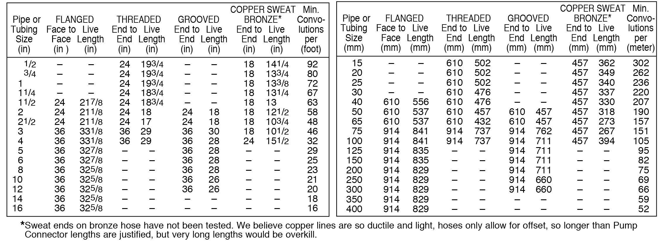

(Spec 24)
Flexible braided hose shall consist of corrugated tube with braided wire to prevent elongation due to pressure thrust. Flexible braided stainless steel hose shall be manufactured using type 304 stainless steel braid and hose with one raised-face fixed and one floating steel plate flange. Grooved ends may be used in sizes 2” through 12” (50mm through 300mm). Welding is not acceptable. Sizes 2-1/2” (65mm) and smaller may have threaded male nipples. Flexible braided hose 4” (100mm) or smaller, with copper sweat ends, may have stainless steel hose and braid for gas service or bronze hose and braid for water service.
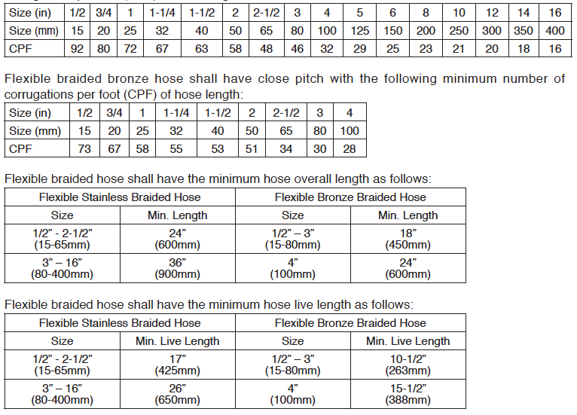

Flexible braided hose shall have a minimum burst pressure of four times the rated pressure at 70° F (21° C). Forces required to displace hoses at operating pressure shall be determined by testing, and certified by a professional engineer. Submittals shall include original test data showing force/ displacement at operating pressure, fittings, material, live lengths, number of corrugations per foot and safety factor at pressure ratings. Hoses shall be type FFL, MN, GWN or CPSB as manufactured by Mason Industries, Inc.

SPECIFICATION P (From VCS-100)
Flexible stainless steel hoses with a safety factor of 4 shall be manufactured using type 304 stainless steel braided hose with one fixed and one floating raised face carbon steel plate flange. Fittings must be 304 Stainless on Stainless lines. Sizes 21/2” (65mm) and smaller may have threaded nipples. Copper sweat ends, 4” (100mm) and smaller, may have SS (gas service) or Bronze (water service) bodies. Grooved ends may be used in sizes 2” (50mm) through 12” (300mm). Welding is not acceptable. Minimum lengths, minimum live lengths and minimum number of convolutions per foot to assure flexibility are as tabulated. Shorter lengths are not acceptable.

Hoses shall be installed on the equipment side of the shut off valves horizontal and parallel to the equipment shafts wherever possible. Submittals shall include original test data showing force/displacement, fittings, material, live lengths, number of corrugations per foot and safety factor at pressure ratings. Hoses shall be type BSS or CPSB as manufactured by Mason Industries, Inc.

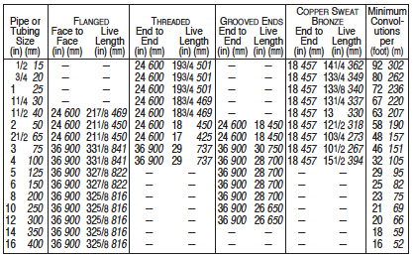

VH-30-5 (From VH-30-5 Bulletin)

VEE SPECIFICATION
Piping and equipment connections shall be protected against seismic damage by the insertion of braided flexible hose Vee assemblies rated for ±4” (100mm) seismic motion in all planes. Should the application include ±6” (150mm) thermal movement or thermal movement alone, install the Vee so the thermal movement is axial.

All submittals shall include a recognized test report, covering the full range of the specified movements at the operating pressures. Forces required to move the Vees shall not exceed the values below. Vees shall have a minimum burst pressure of four times their rated pressure. Vees in steel lines shall have stainless hose and braid with threaded ends, weld ends or floating flanges. In stainless lines, all fittings in contact with the media must be stainless as well. Copper lines, bronze hose and braid with copper or bronze fittings. Guiding and anchoring shall be as designed by the manufacturer, stamped by a PE and included with the submittals. Submittals shall include Movement-Force Test Reports. 60 Degree Vees, ADA Resilient Anchors and ASG Sliding Guides, all as manufactured by Mason Industries, Inc.

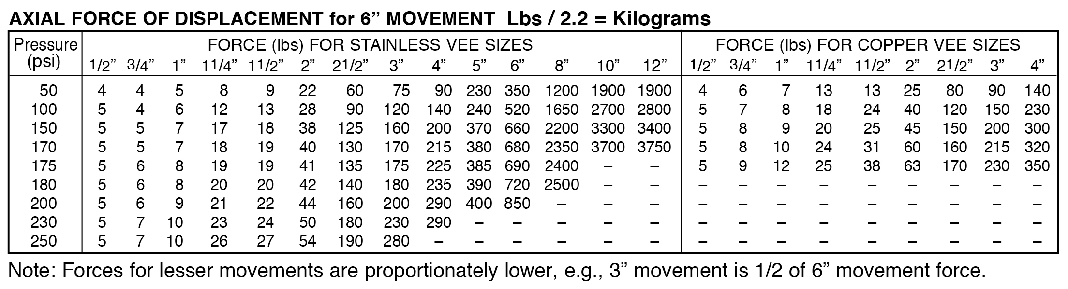

VT-32 (From VT-32 Bulletin)

VEE SPECIFICATION
Piping and equipment connections shall be protected against seismic damage by the insertion of braided flexible hose Vee assemblies rated for ±4” (100mm) seismic motion in all planes. Should the application include ±6” (150mm) thermal movement or thermal movement alone, install the Vee so the thermal movement is axial.

All submittals shall include a recognized test report, covering the full range of the specified movements at the operating pressures. Forces required to move the Vees shall not exceed the Mason values below. Vees shall have a minimum burst pressure of four times their rated pressure. Vees in steel lines shall have stainless hose and braid. Copper lines, bronze hose and braid. Guiding and anchoring shall be as recommended by the manufacturer. 60° Vees shall be as manufactured by Mason Industries, Inc. Submittals shall include Movement-Force Test Reports.

ASG-33-1 (From ASG-33-1 Bulletin)
Pipe guides shall be manufactured with stainless steel wrapping the carbon steel foot where it passes through horizontal U guides similarly lined to prevent corrosion. The baseplate shall have multiple holes for bolting to beam flanges or flat surfaces. Bases may be welded in position in lieu of bolting. Height must be adjustable to accept different thicknesses of insulation. Guides shall be professionally load rated for bottom, overhead, side mounted or riser positioning to provide both load bearing and guiding capabilities. Submittals shall include load ratings in all modes. Guides shall be type ASG as manufactured by Mason Industries, Inc.

BJ-35 (From BJ-35 Bulletin)

BALL JOINT SPECIFICATION
Steel Ball Joints shall have weld ends or fixed and floating flanges. The thrust free, ball and socket arrangement shall allow 360° of intermittent rotation and a minimum rocking motion of ± 7.5 degrees. Seals are guaranteed by the high pressure injection of graphite packing in a cavity between reinforced hard graphite and steel rings. The ball and steel seal retention rings shall be plated with a minimum 1 mil thickness of crack free hard chrome. The socket must incorporate an adequate number of packing cylinders for uniform distribution of the graphite seal. All cylinders must incorporate a valve to prevent blowback should pumping additional sealing material become necessary while under full line pressure. Minimum ratings are 250 psi (17 Bar) @ 480°F (250°C).

